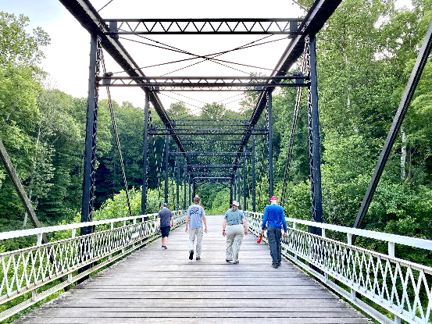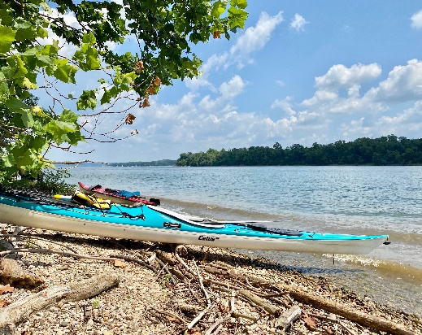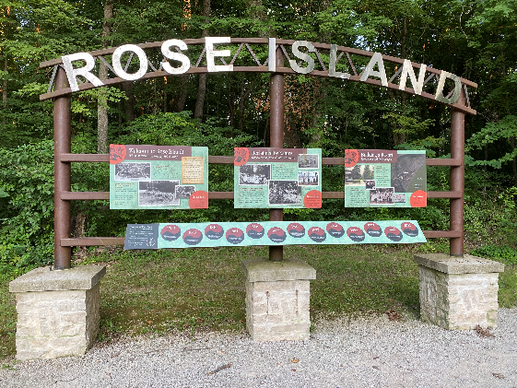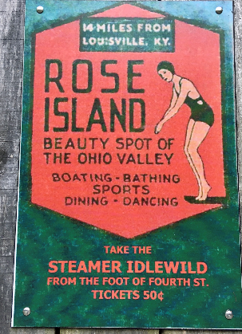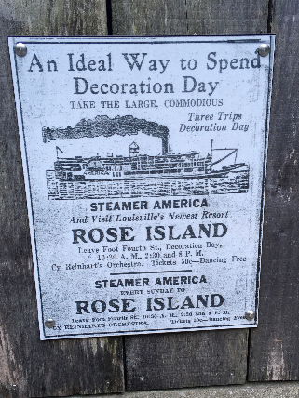

**Inline image**

**Trip Report**

**Location:** Ohio River Paddle from Charlestown State Park

**Date**: July 25th and 26th

**Sponsors:** Julie Sinclair and Andy Thieneman

 We had a great time on the Ohio River paddle, despite very hot temperatures. Eight kayakers joined the trip including new 2 members to the club.

On Saturday, we paddled down river to the toll bridge and stopped at 12 Mile Island. 12 Mile Island is maintained by the Knight of Columbus with mowed grounds, small trails, porta-pots, campfire rings and a shelter, we are already thinking of next year’s trip. J We paddled a total of 8 miles and due to the extreme heat – decided to stop for the day. [Saturday evening](x-apple-data-detectors://3) after camp dinner, we met at the trail head to hike to Rose Island. This trail is less than a mile but on a very steep hill down towards the Ohio. We crossed a restored steel bridge and walked the trails at Rose Island, an old 1920s  amusement park. Quite interesting to see the remaining structures and read the historical plaques.

Sunday, we met a the boat ramp and padded up river to 14 Mile Creek. The creek was pretty wide and shaded and we were able to get about 3 miles up. Our total paddle distance on Sunday about another 8 miles. Charlestown State Park is huge with an interesting history. Very nice time.